Atitit 压缩文件zip总结

注意孔目录 以及 递归目录

/springbootUpload/src/springbootUploadPkg/ZipUtilCompressPart.java

**File** **file** = **new** **File**("D:\\00000up\\A157BB5CDF77567B41E9222C07AF41DA.png");

**String** **zipFileName2** = "d:\\00000up.zip";

**String** **relativePath** = "zipdir/";

**ZipOutputStream** **zos** = **new** **ZipOutputStream**(**new** **FileOutputStream**(zipFileName2));

// 创建一个zip压缩项

**ZipEntry** **entry** = **new** **ZipEntry**(relativePath + file.**getName**());

// 放入zip文件输出流

zos.**putNextEntry**(entry);

// 将文件读取输入zip文件里面

**IOUtils**.*copy*(**new** **FileInputStream**(file), zos);

zos.**flush**();

zos.**close**();

**System**.***out***.**println**("--f");

**String** **directory**="D:\\00000up";

.jar";

// System.out.println(unzip_filelist(f));

*zipV2saa*("d:\\00000up.zip", directory);

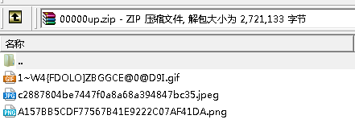

~~zipV2saa~~("d:\\00000up.zip","00000up/", directory);

